**CROSS DOMAIN USE CASE**

LUCIA lives in perugia (northern apennines, Italy)

* SHE WANTS TO KNOW WHICH ARE THE RESEARCH INFRASTRUCTURES MONITORING EARTH INSTABILITIES (E.G. EARTHQUAKES) NEARBY HIS HOME
* LUCIA DOES A WEB RESEARCH SHOWING THE EPOS (ICS) WEB SITE
* LUCIA PERFORMS A SPATIAL RESEARCH (LATITUDE LONGITUDE AROUND PERUGIA, ITALY)

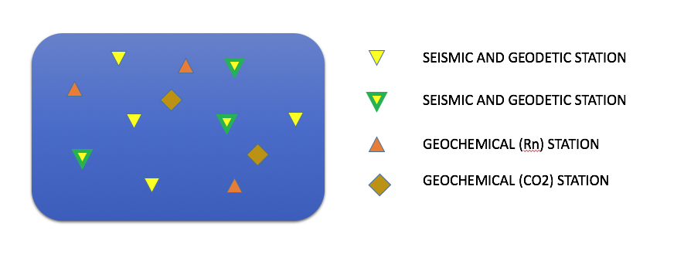

seismic station

sesimic and geodetic station

Geochemical (Rn) station

Geochemical (co2) station

* LUCIA cliks to find out the station charactreristics (FDSN station – GLASS GNSS station – geochemical station info) and where/HOW he could get the data from (e.g. ICS SITE ITSELF oR EIDA, GLASS and FRIDGE)
* LUCIA is inteersted in the seismic data in terms of earthqaukes activity so he asks for the events occurred IN the area (ICS has to talk with a FDSN event)

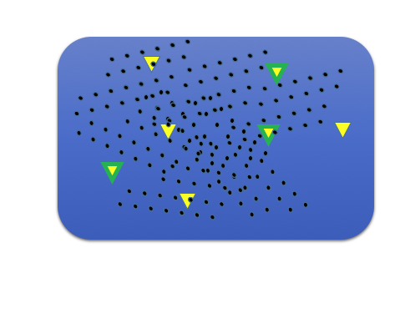

* LUCIA is inteersted in understanding the size (e.g. magnitude) of the events so he clicks on the points (Origin time, lat lon mag …)
* LUCIA wants to see if there is any correlation between seismic events and surface geology (sorry but LUCIA is not a scientist :-) so he overlays a geological map of the area
* then LUCIA is inteersted in understanding the events occurrence so he asks for a plot showing the number of events versus time (e.g. time series showing number of events per day in the selected area)

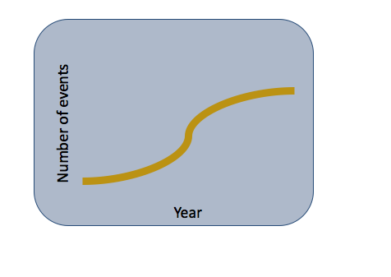

* LUCIA is inteersted in understanding if this area was INTEREStED by seismic activity in the past (e.g. historical earthquakes from ahead)

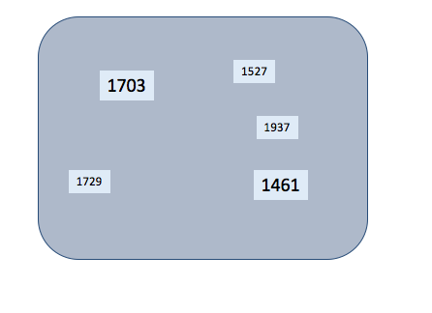

* LUCIA is inteersted in understanding the size (e.g. magnitude) of the events, the closest villages
* LUCIA doesn’t know the geochemical stations thus he goes back to map 1 and click on one of the co2 geochemical stations
* he reads the description and then he wants to see the co2 release versus time compared to the meteo temperature (e.g. time series swhowing the co2 values versus time using the declared sampling rate measurement)

**LUCIA is happy and now she is ready to vote for remaining in EU!!**